Exploring Dallas-County Vehicle Crash Data from 2020-Nov2023

Aayush Desai and Taylor Fisher

# Our Data Source

We acquired our data by utilizing the Texas Department of Transportation’s Query Builder for their crash report database.

Query Builder: <https://cris.dot.state.tx.us/public/Query/app/query-builder>

This tool allows you to pull crash data from the crash, unit, and person dimensions surronding crashes in Texas.

We pulled Crash Data in Dallas County from Jan. 2020 to Nov. 2023 on both the Crash and Unit Dimensions.

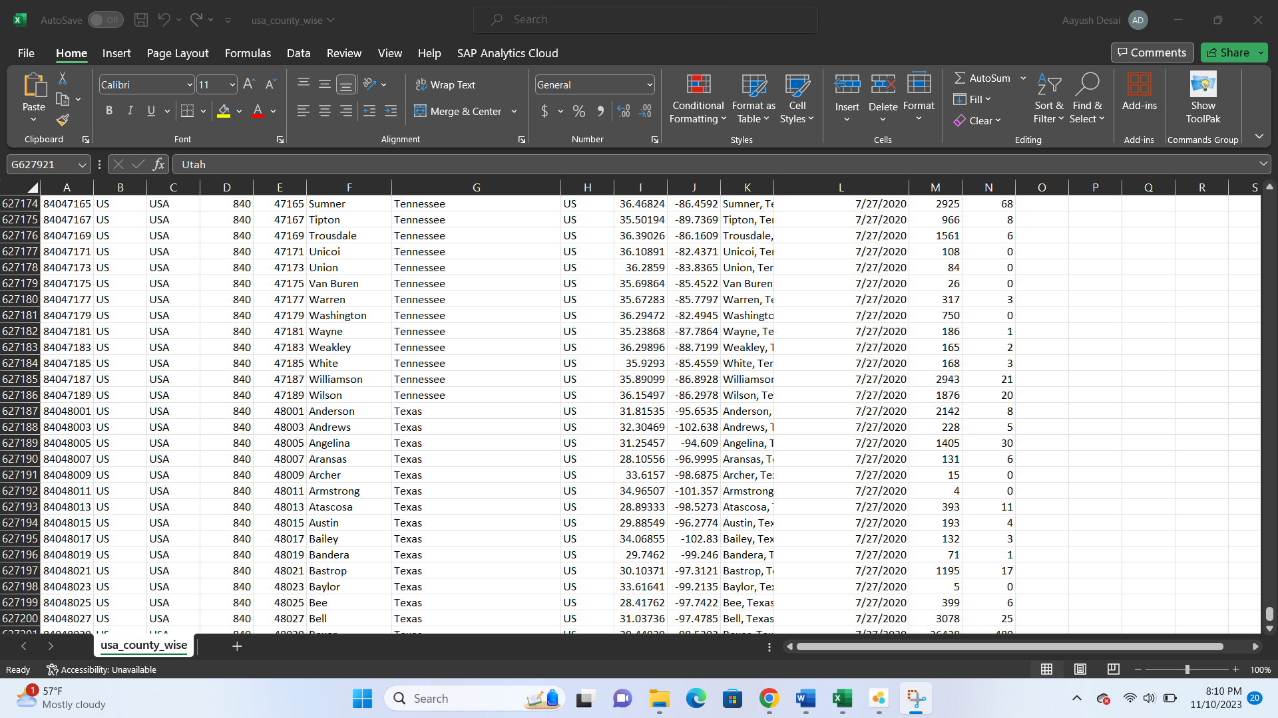

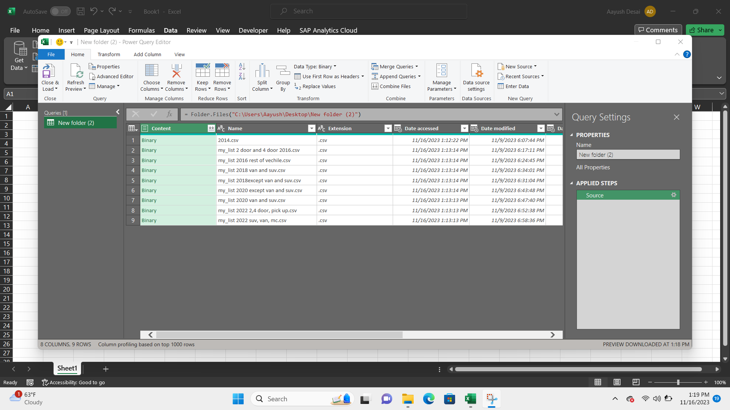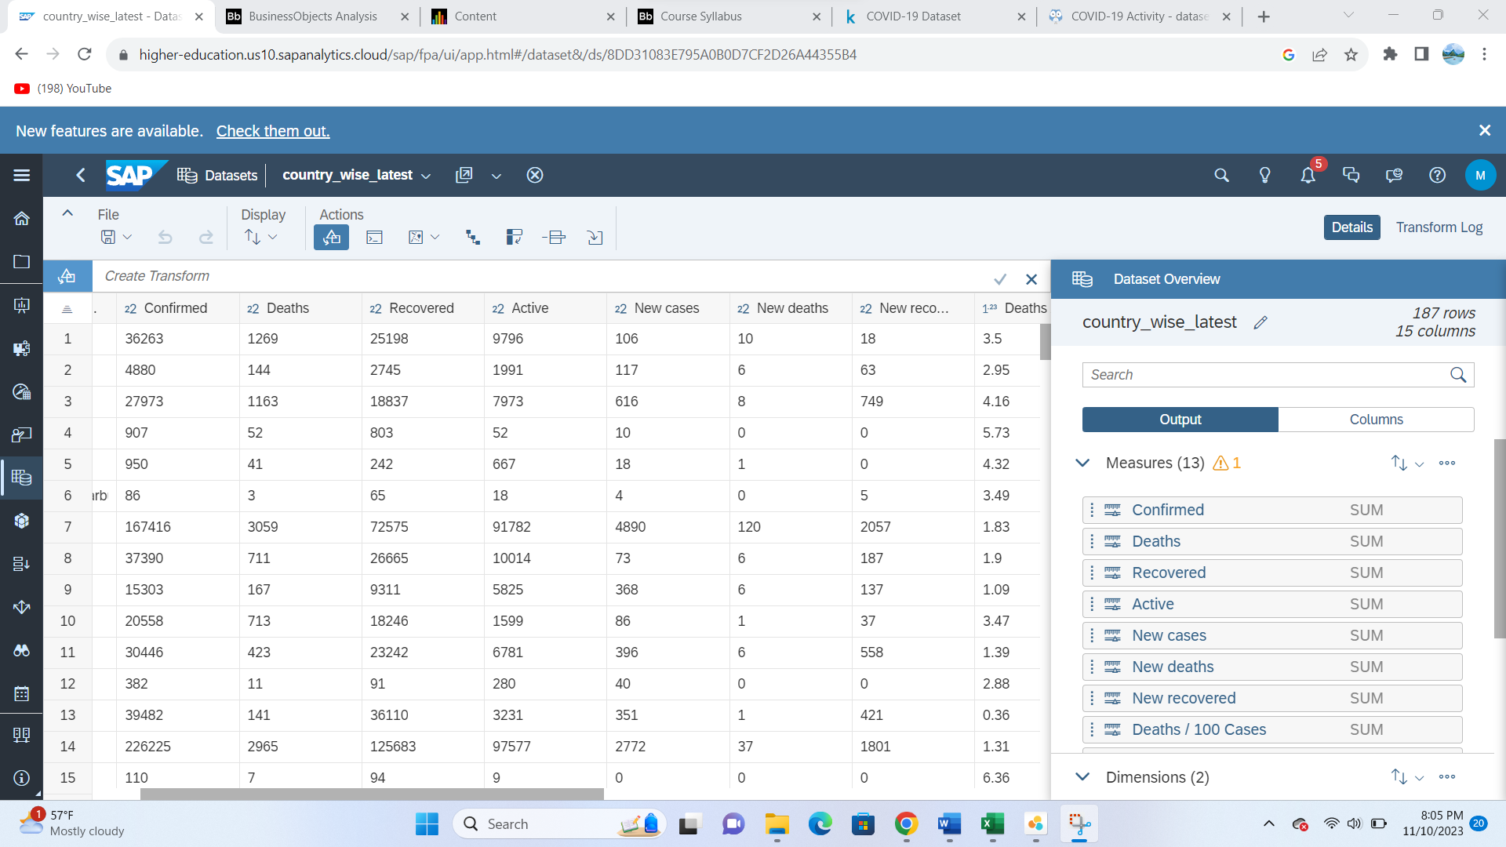

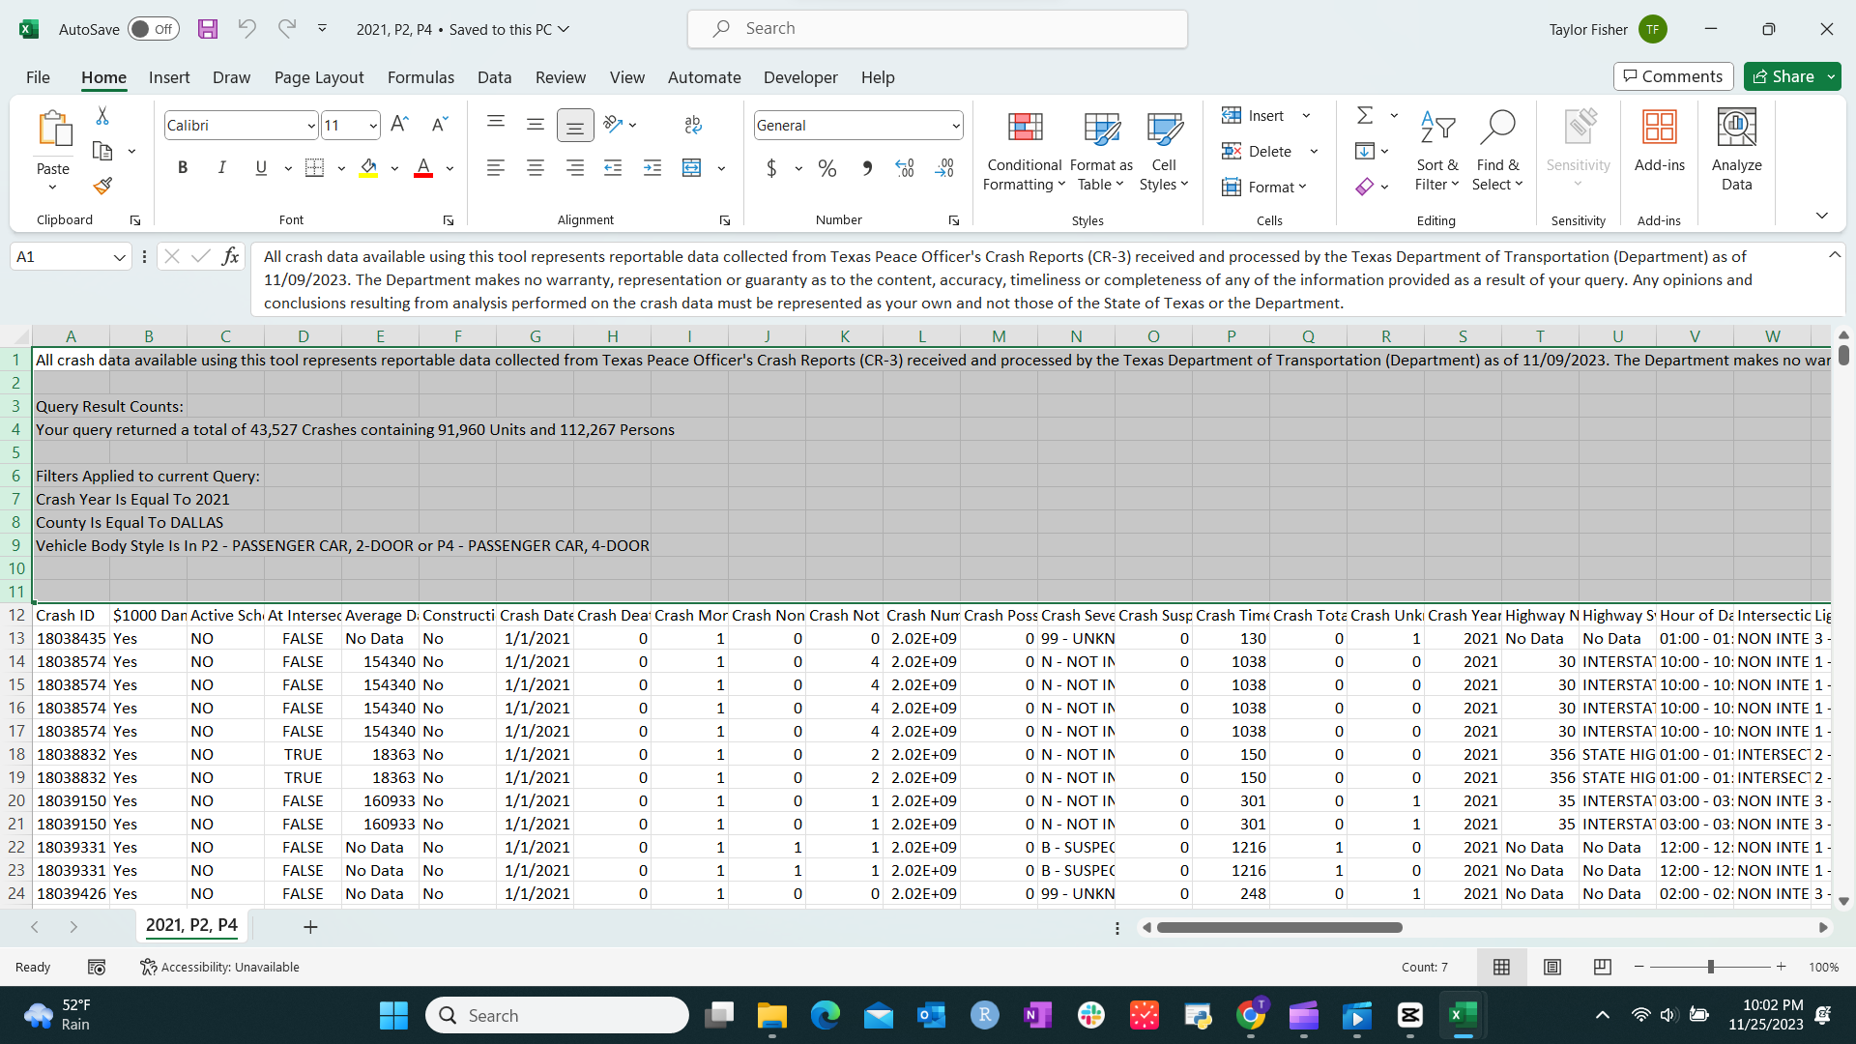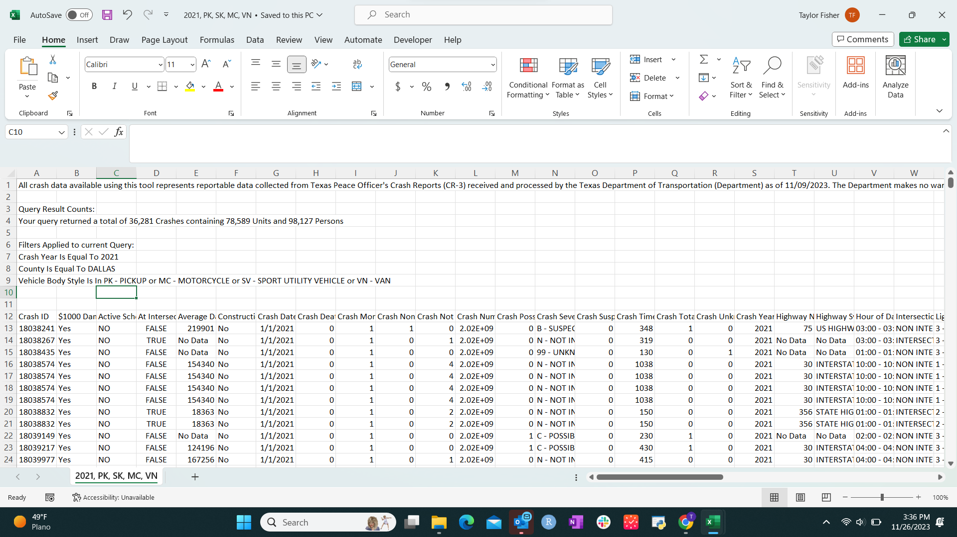

# 

# Data Cleansing

Due to the size of the Data we had to pull multiple queries saved as .csv files, ensure consistent formats were applied, and combine the dataset sets. From here we conducted data cleansing procedures using both Excel and SAP Cloud Datasets.

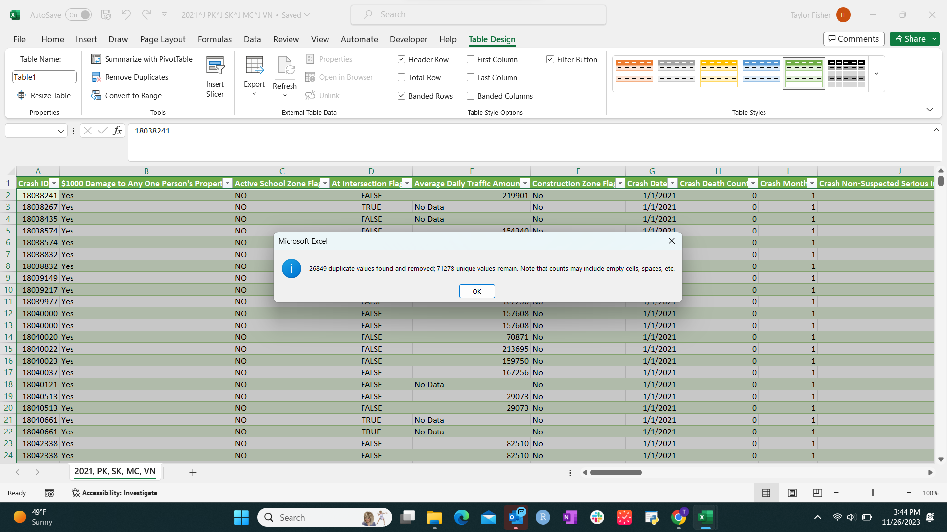

# 

# Data Modeling

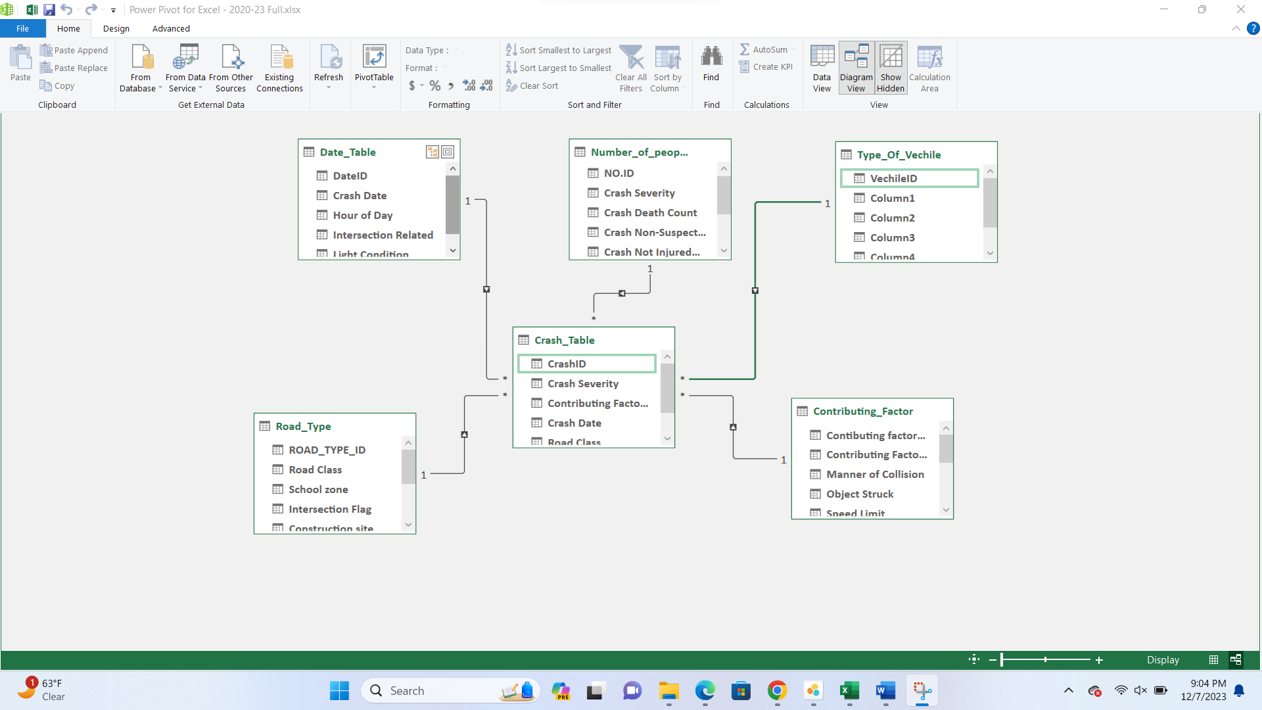

# Visualizations

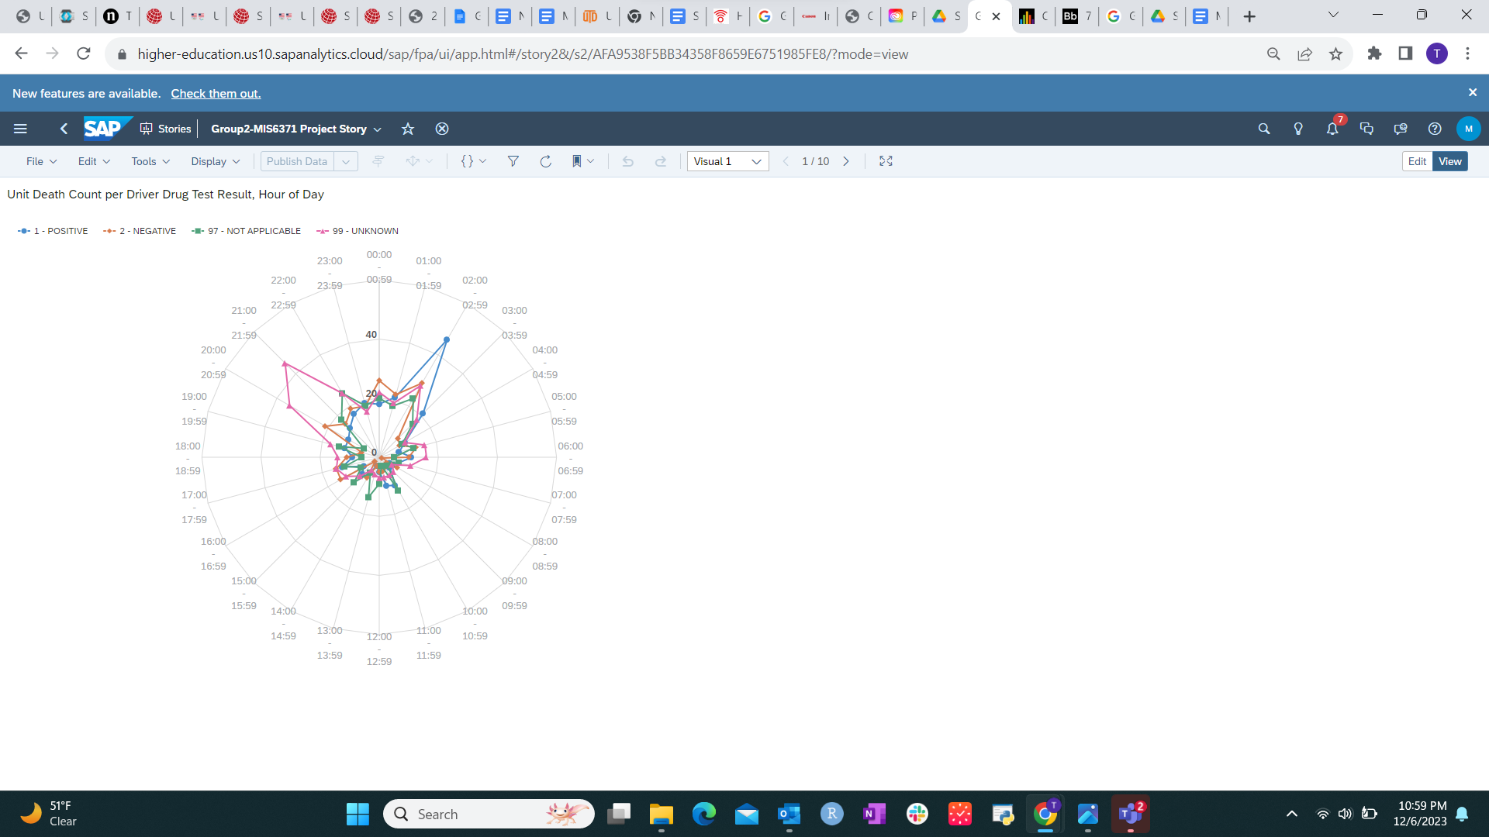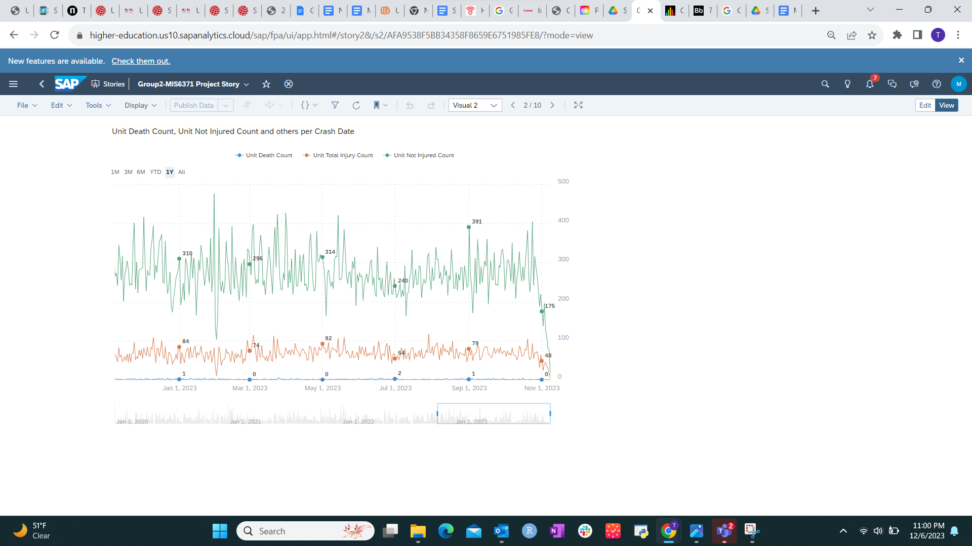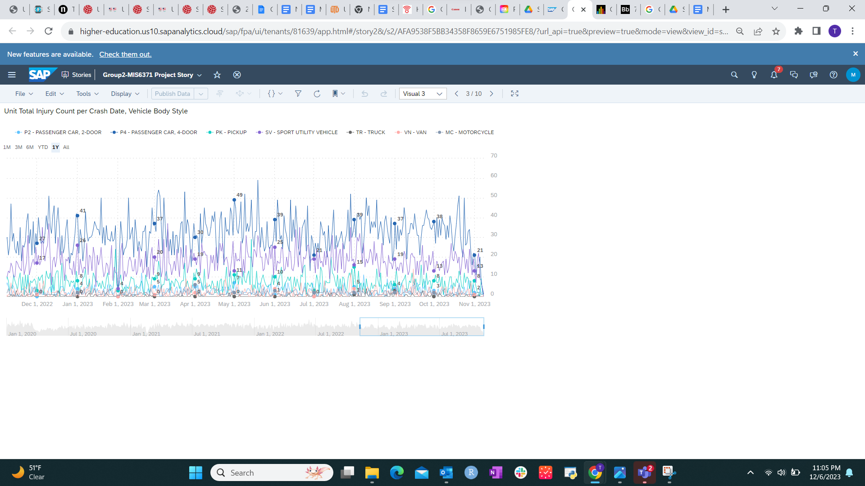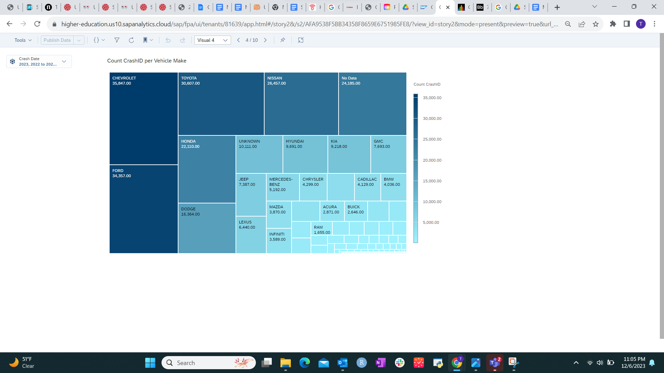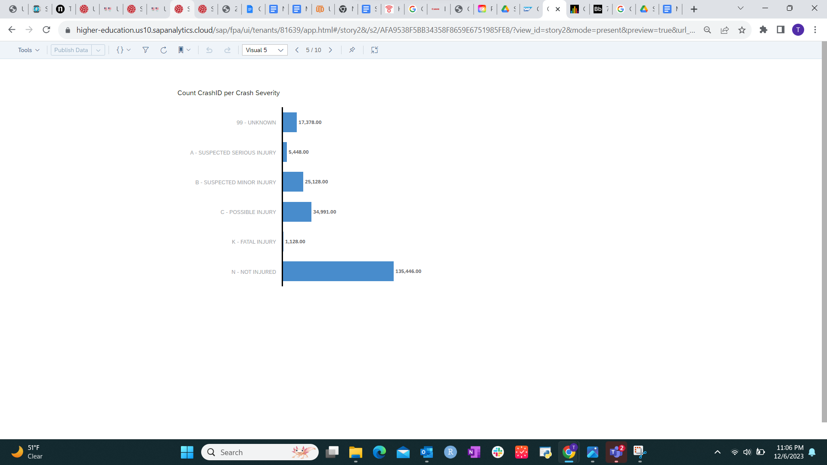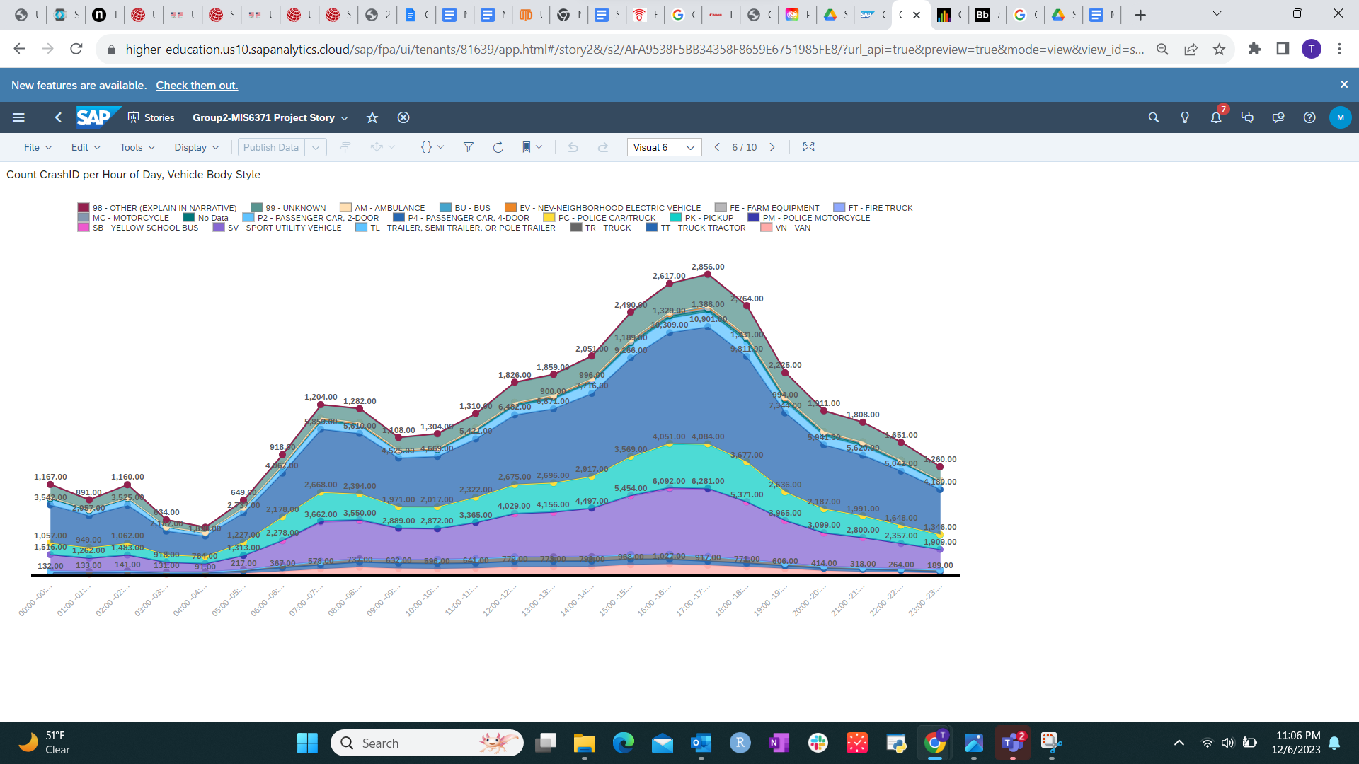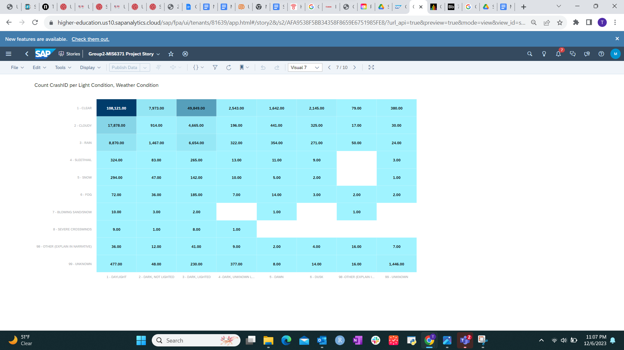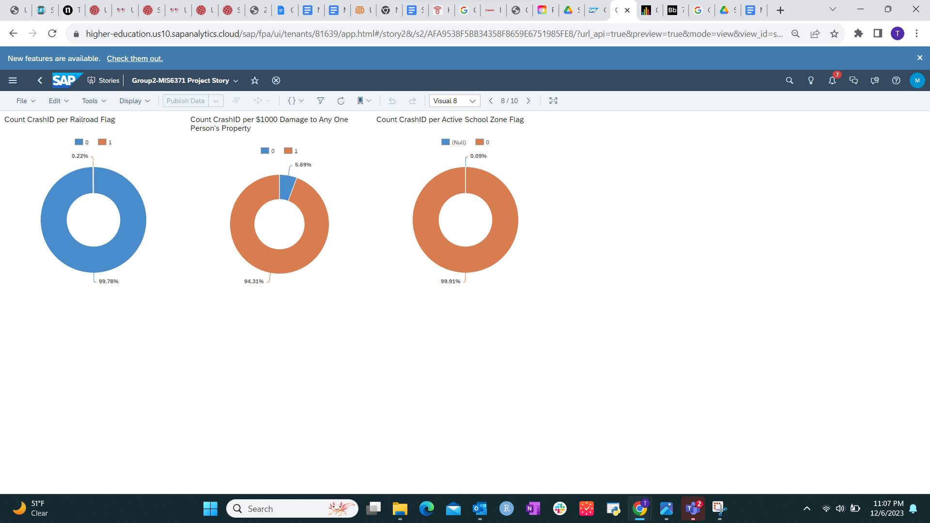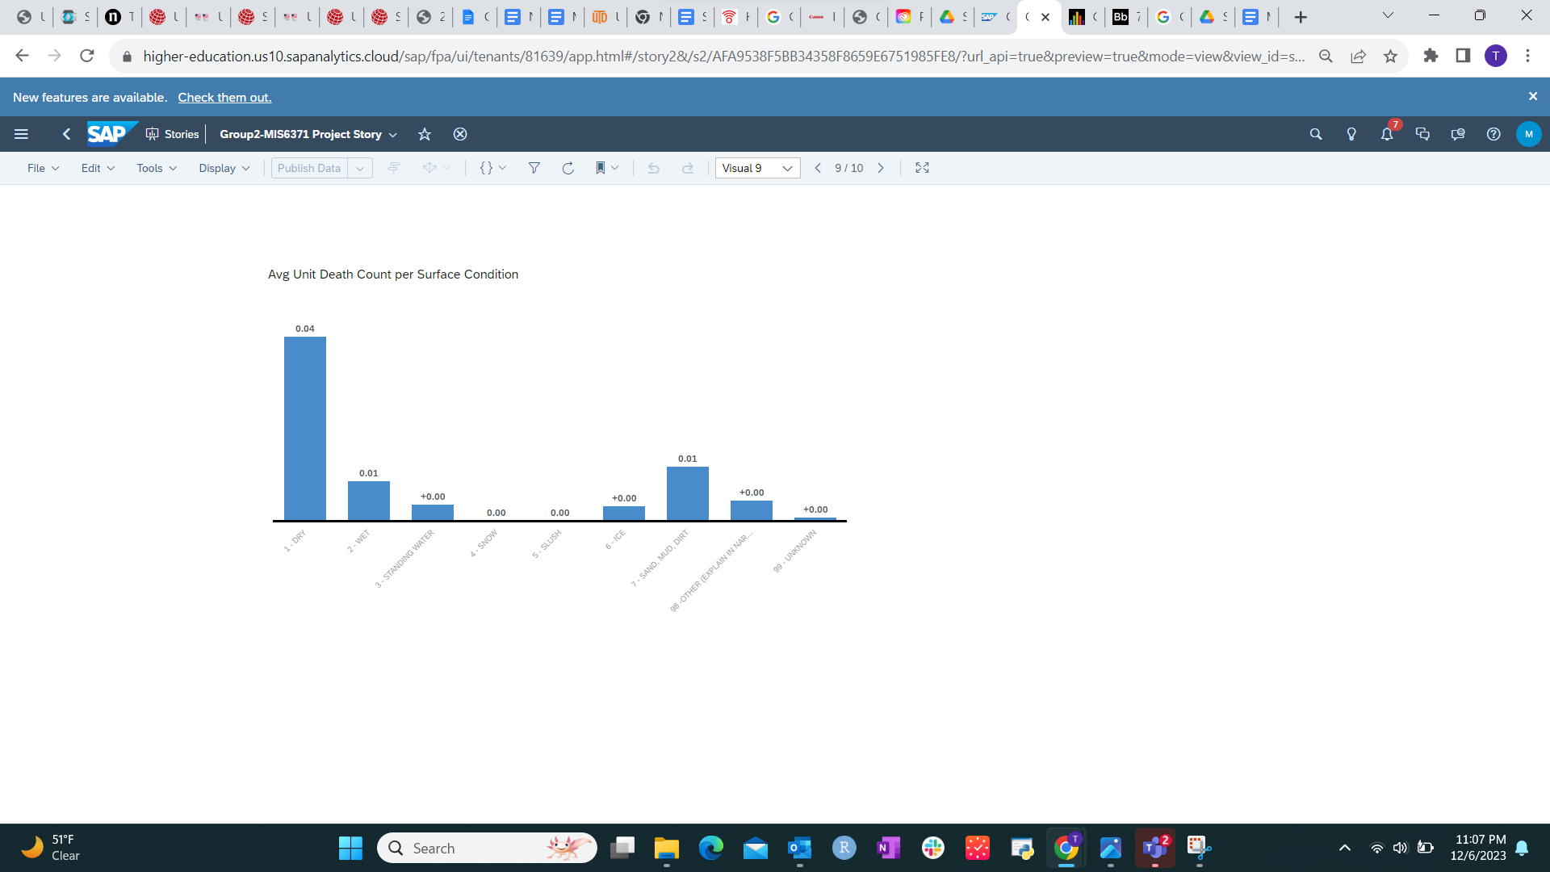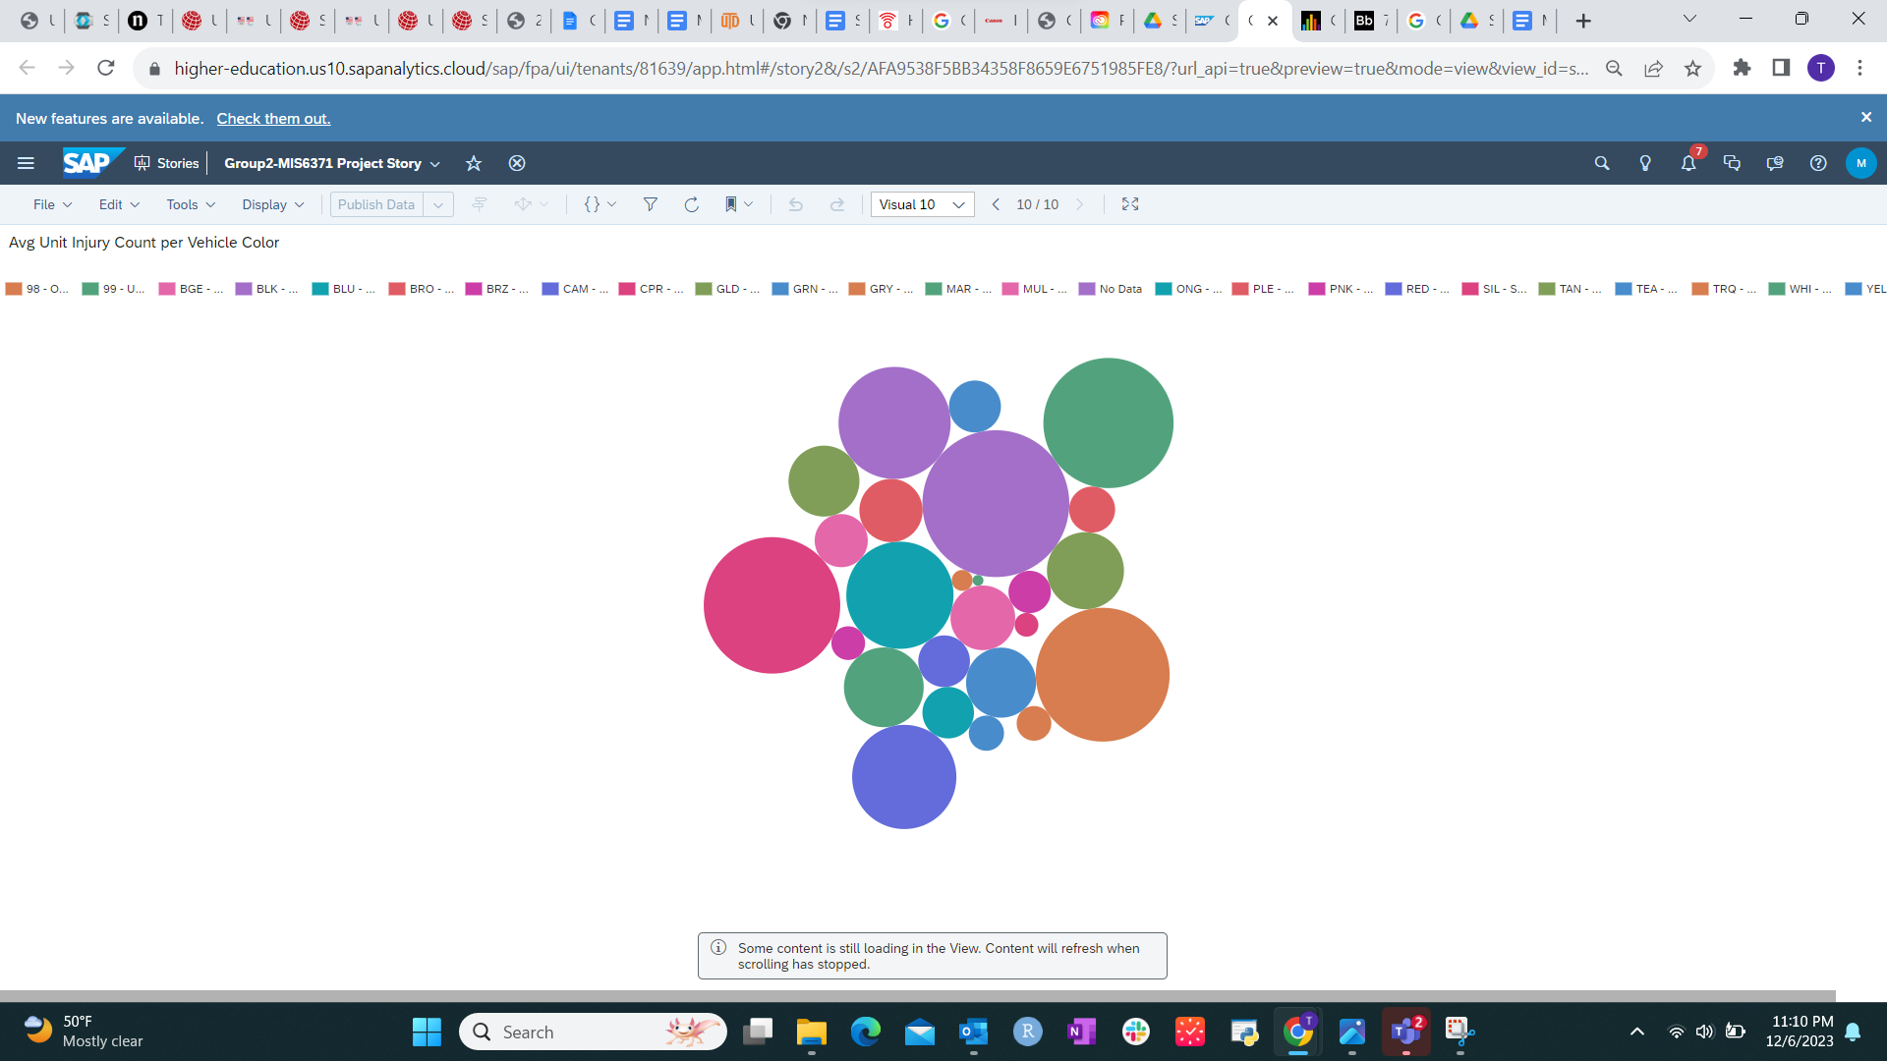

# 

# Predictive Scenario

Target: Unit Total Total Injury Count

